2. Choosing Surge Protection

2.1 Risk assessment

Historically lightning protection was concerned only with the protection of buildings and structures. Since buildings were constructed of masonry and timber. they constituted a significant fire hazard. Traditional lightning protection comprising air terminals, downconductors and earthing systems were developed.
Today modern structures containing electrically conductive elements such as steel frames, metallic cladding and reinforced concrete are defined as self-protecting and the traditional approach is no longer applicable.
As electrical services were introduced into buildings little thought was given to protecting these services against the indirect effects of a lightning strike even though the effects of an indirect strike could often be more damaging than a direct strike to a modern building.
This situation is now recognised in most of the world’s lightning protection standards. The IEC standard (IEC62305-2) presents a risk assessment procedure to assess the need for direct and/or indirect lightning protection. The Australian Standard AS1768 provides an Excel spreadsheet to simplify the risk assessment procedure. A typical cover page of this spreadsheet is shown in figure 1.

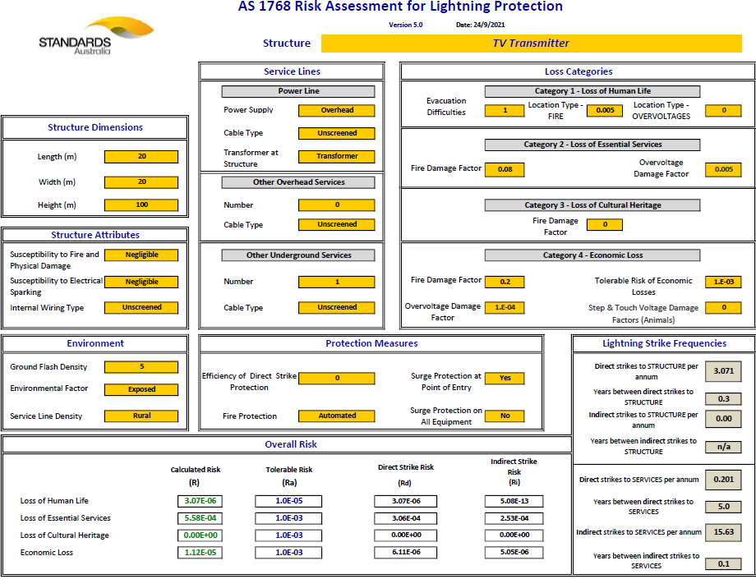
Figure 1. Risk Assessment from AS1768
In this example the structure is all steel and therefore self-protecting. The risk assessment determines that only surge protection is required.

2.2 Sources of lightning damage
The risk assessment procedure takes into account four sources of lightning damage and the analysis presents the frequency of these events, shown in the bottom right table in figure 1. These four sources are:
- S1 Direct strike to the structure
- S2 Strike near the structure
- S3 Direct strike to a service
- S4 Strike near a service
This is summarised in figure 2 (from both IEC and AS standards)
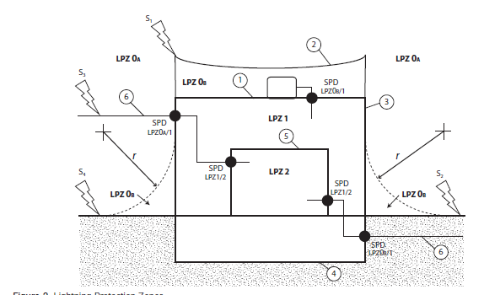
Figure 2. Sources of Lightning Damage

The risk assessment indicates the need for surge protection whether at the point of entry of services into the structure or further downstream at distribution boards and final circuits (for example equipment cabinets). The rating of surge protection devices (SPDs) depends upon their location in the distribution network. Type 1 SPDs are located at the boundary of lightning protection zone 0_{A} (LPZ0) and the internal distribution wiring in LPZ1, at the main switchboard. A direct strike to the service or an earth potential rise due to a direct strike to the structure can cause a proportion of the strike current to flow through the Type 1 SPD and along the service line.
2.3 Recommended surge ratings
Whilst the risk assessment can provide an indication of the rating of the various SPDs, if the structure is self-protecting this can prove difficult. Table 1 provides recommendations for SPD ratings at each lightning protection zone boundary.
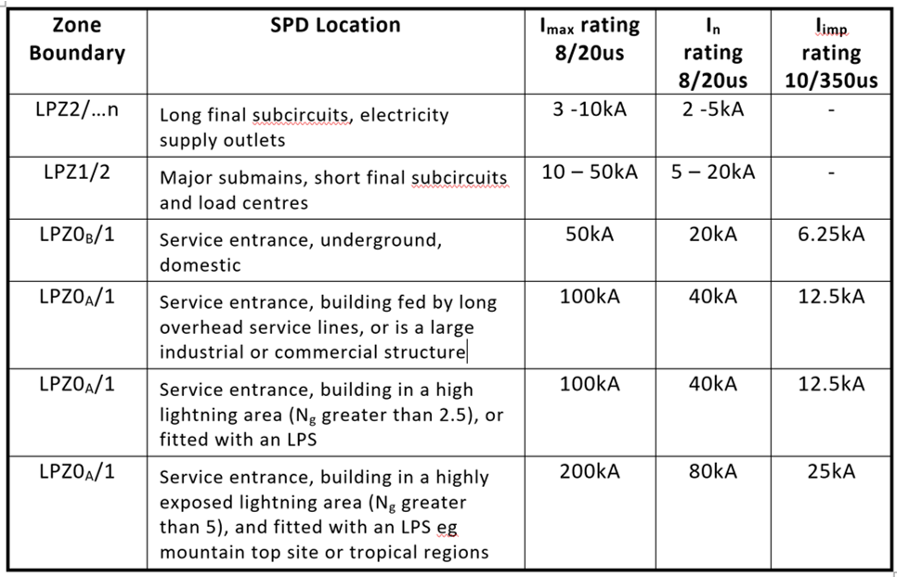
Table 1. Recommended surge ratings – power from AS1768
Table 2. shows recommended surge ratings for SPDs protecting signal and data lines.
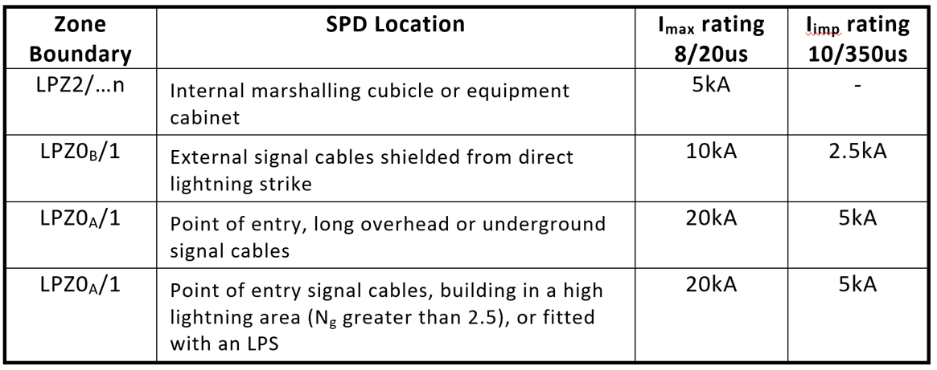
Table 2. Recommended surge ratings – signal and data from AS1768
The IEC standards recognise that a direct lightning strike may be modelled by a current waveform with a rise time of 10us and a decay of 350us (10/350), hence Type 1 SPDs have a 10/350us rating as well as an 8/20us rating. After the LPZ0/1 boundary the subsequent current may be modelled by an 8/20us waveform, hence Type 2 and Type 3 SPDs have an 8/20us rating.

2.4 Surge protection technology
Use the drawings on page 6 of handbook V5.0
Surge Diverters, SD (Type 1/2/3)
Surge diverters are one port shunt connected devices. Novaris surge diverters are voltage clamping devices using metal oxide varistors (MOV). They can be used in all lightning protection zones and have ratings up to 200kA (8/20us) or 25kA (10/350us) per phase.
HRC fuses or preferably Novaris surge circuit breakers, SCB, are recommended for overcurrent protection of surge diverters.
Surge diverters are not recommended for installations where sustained overvoltages may be present. Hybrid spark gaps, HSG, are designed for this purpose.
Spark Gaps, SG (Type 1)
Spark gaps have high surge ratings and are suitable for installations with highly exposed overhead LV power lines in high lightning areas. Spark gaps have a crowbar effect that can cause AC current to flow after being triggered. This is called follow on current. For this reason, SCBs cannot be used for overcurrent protection of spark gaps. Fuses or circuit breakers must be used.
Hybrid Spark Gaps, HSG (Type 1)
A hybrid spark gaps combine the advantages of voltage switching and voltage limiting components. They can withstand temporary overvoltages in excess of the line to line supply voltage whist providing performance almost identical to that of a surge diverter.
They have negligible AC follow on current so may be protected by an SCB.
Series Surge Protector, SSP (Type 1/2/3)
Single port SPDs are compromised by the presence of their connecting leads. Typically, voltage drops of 500V per meter can be expected under impulse conditions.
For circuits that are more sensitive the two port SSP provides a means of eliminating the shunt connected leads by being placed in series with the load.
SSPs are suitable for applications such as UPS inputs, rectifiers, VSDs and motors.
Surge Filters, SF (Type1/2/3)
Surge filters are true two port SPDs offering exceptionally low let-through voltages capable of protecting highly sensitive electronic loads.
They comprise three stages of protection, primary surge protection, series connected low pass filters followed by secondary surge protection. Current ratings range from 6A to 2000A per phase.
They are particularly suited to the protection of data centres, server rooms, communications and cell sites as well as remote telemetry installations.

